Steps to access a remote device
In order to connect to a remote system over the internet the remote device requires access to port 502 TCP and 47808 UDP.
You can set this up in the router at the remote site.
You will need to use port forwarding to route these ports to the panel with ID=1 at the remote site.
Port 47808 is fixed while the port 502 is user configurable.
The setting can be found in the same advanced settings dialog where you defined the IP address for the controller
- Set up port forwarding on the router to which the device is connected.

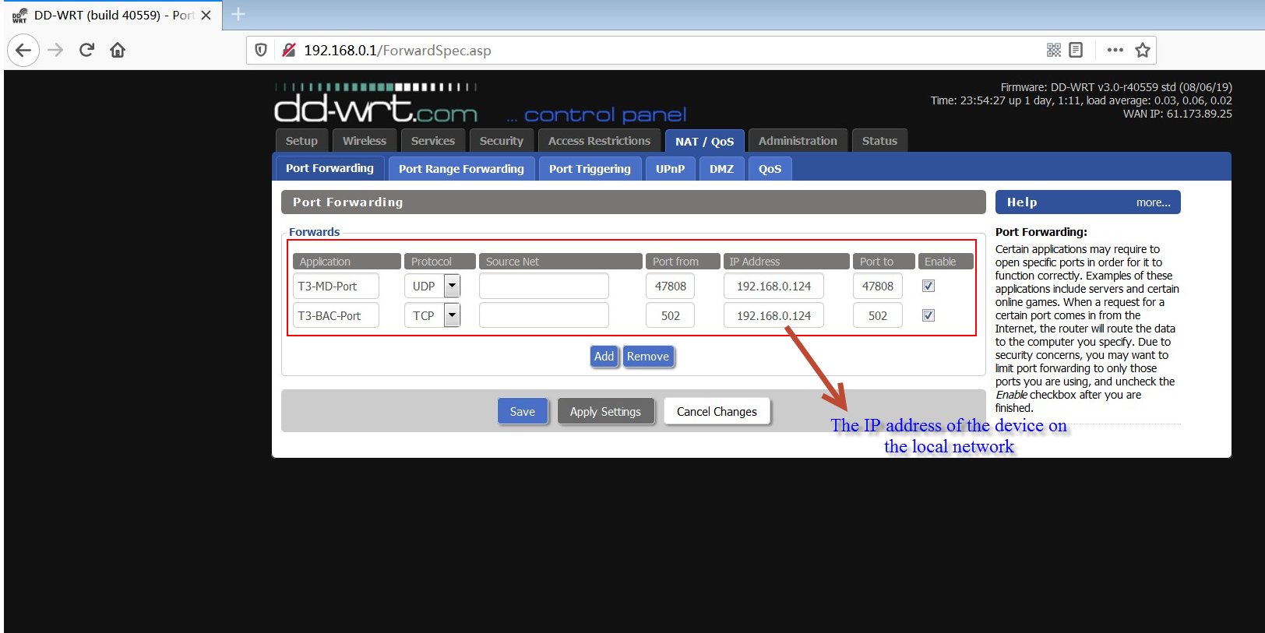

Create a remotely accessible database and select Remote Device for the protocol
Fill in the external IP address of the network on which the device resides , Or fill in the domain name of the network on which the device resides.

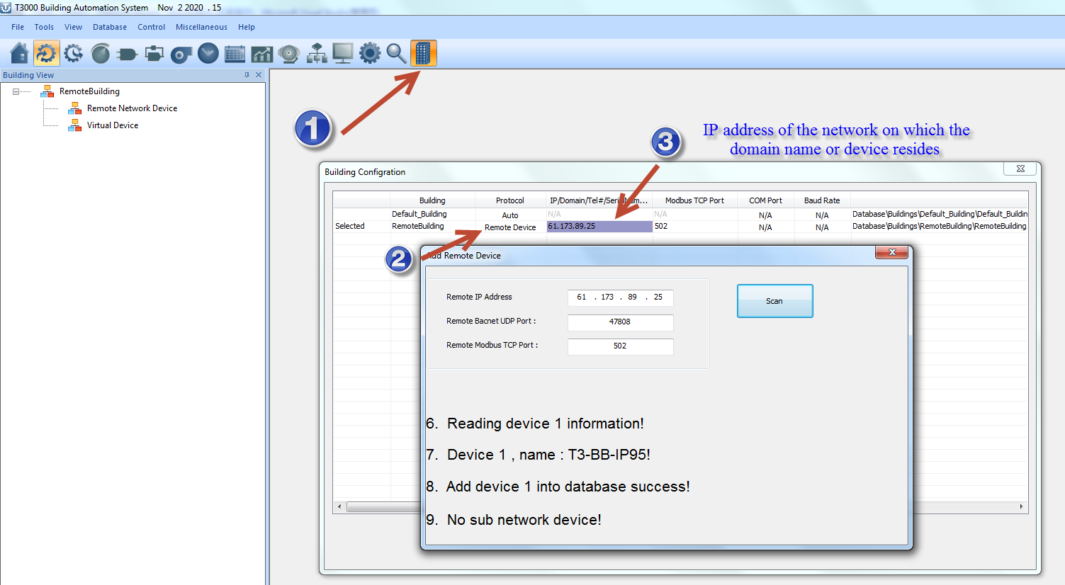

After the scan is complete, the remote device can be accessed normally
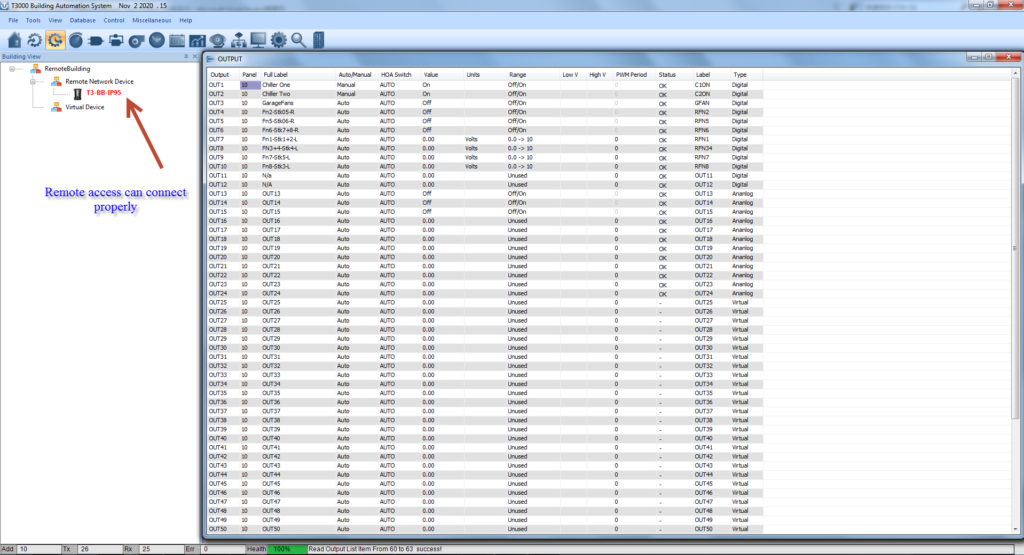

Make sure the gateway of the device is the same as the gateway of the router.
If the gateway of the device is not filled in, or if the gateway is filled in incorrectly, the port forwarding will fail
