How does the T3000 background database work?
- When you create a Building and select the Building, the background database will be automatically created in the corresponding directory of T3000 software.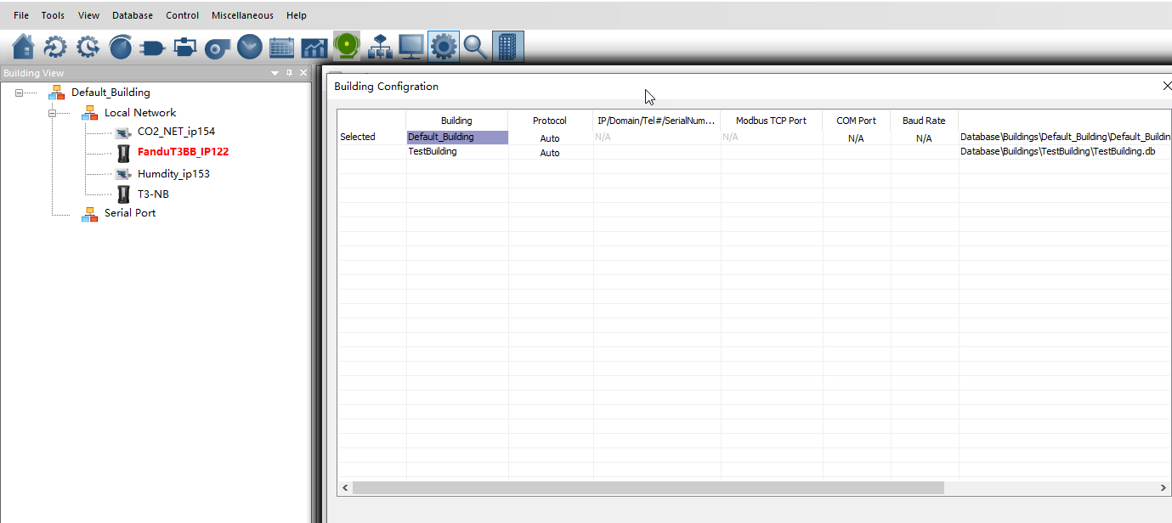 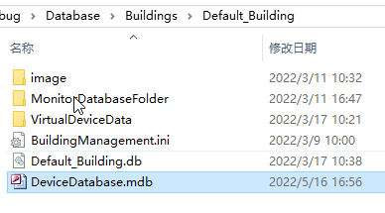
- You can right click and Add Virtual Device, For example, we added a device named T3-BB-1000194(VD)
- 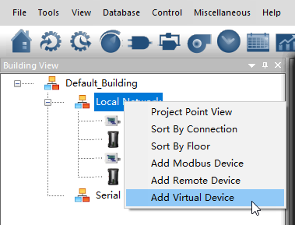
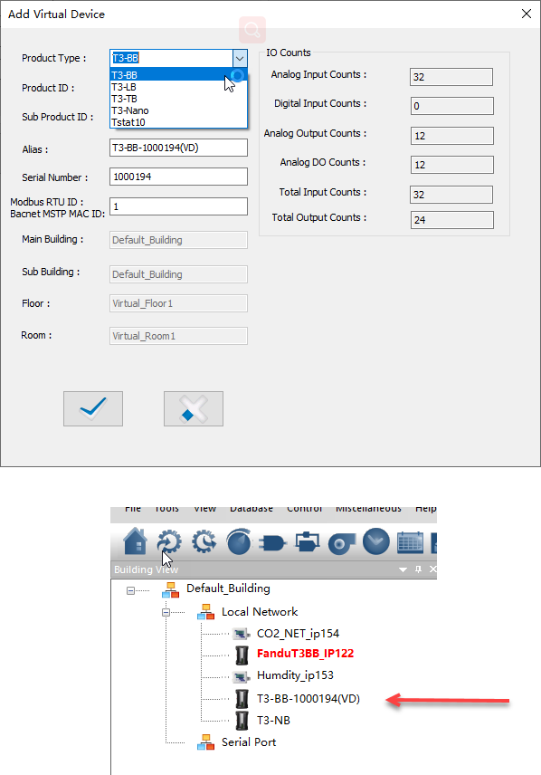
- Select the virtual device (T3-BB-1000194(VD)), or select the online device in the network (FanduT3BB_IP122)
- All data is saved to the database, as well as binary data. (Inputs, outpus, variable, PID, Schedule, holiday, parameters)
- 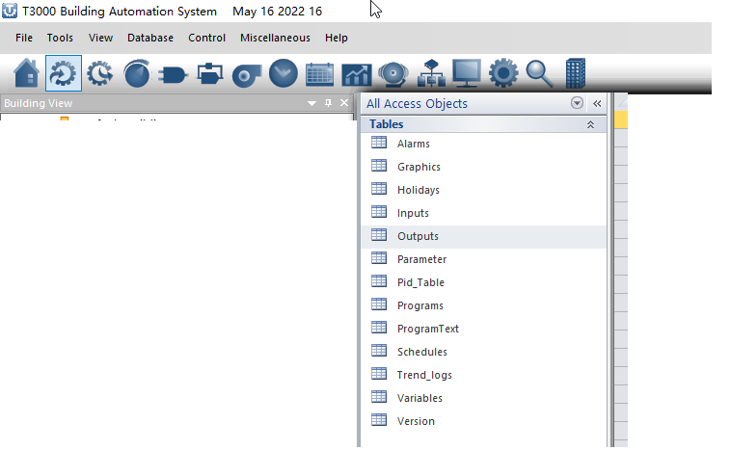
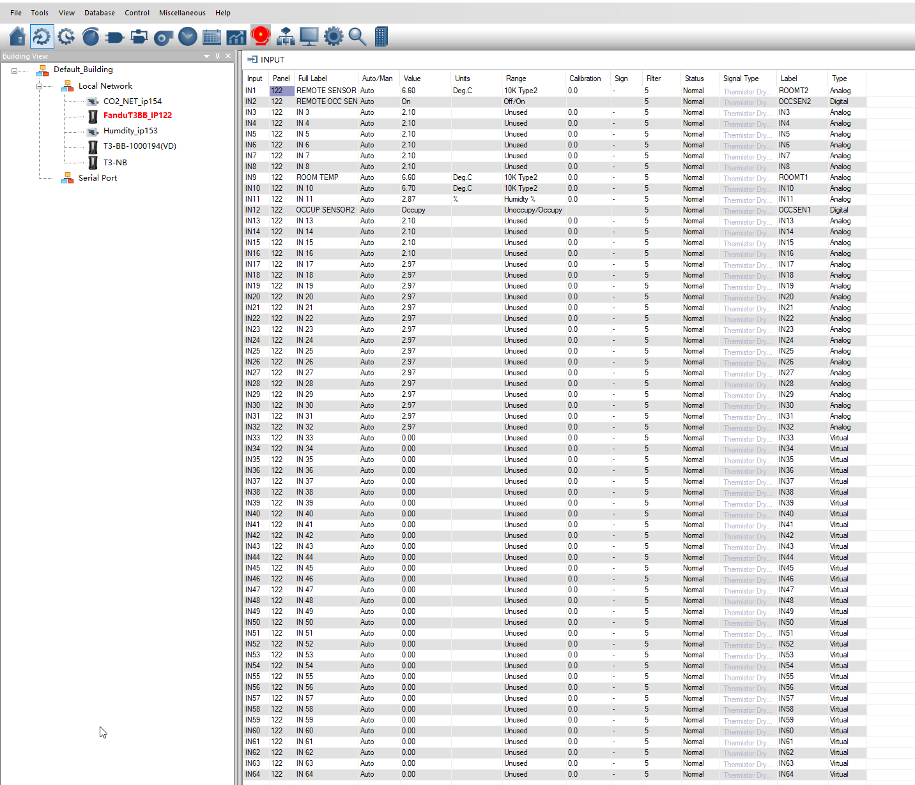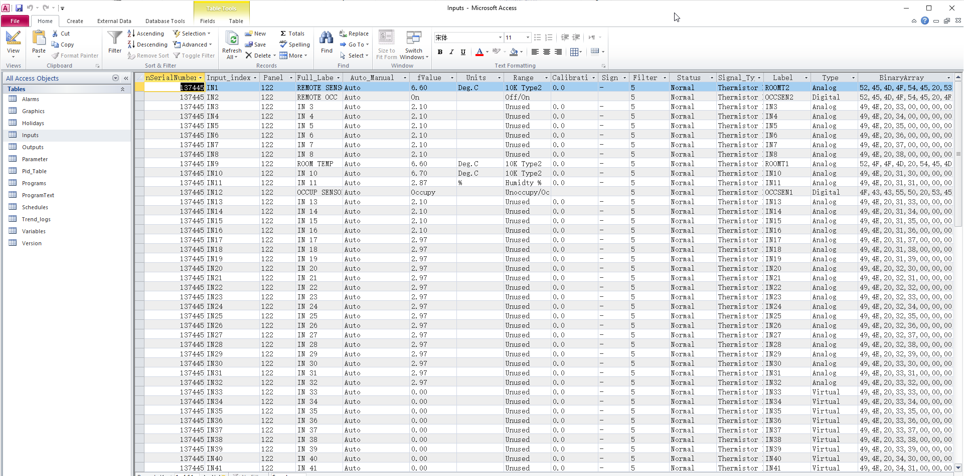
- You can also use program for online or offline devices
